Week 8 – Database Relationship Analysis Using Joins
1. Project Overview
This project focuses on analyzing relationships between tables in an E-Commerce database using SQL JOIN operations. It combines customer, order, product, and payment information to retrieve meaningful data and generate business reports.
2. INNER JOIN Examples
The INNER JOIN operation retrieves records that have matching values in both tables.
Example 1: Customer Details with Orders
SELECT C.Customer_ID, C.Customer_Name,
O.Order_ID, O.Order_Date, O.Order_Status
FROM Customer C
INNER JOIN Orders O
ON C.Customer_ID = O.Customer_ID;
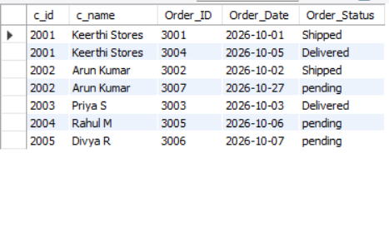
Example 2: Orders with Payment Information
SELECT O.Order_ID, O.Order_Date, O.Order_Status,
P.Payment_ID, P.Payment_Mode, P.Payment_Status
FROM Orders O
INNER JOIN Payment P
ON O.Order_ID = P.Order_ID;
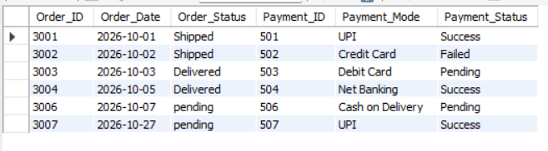
Example 3: Products Purchased by Customers
SELECT C.Customer_Name, O.Order_ID,
P.Product_Name, OD.Quantity, P.Price
FROM Customer C
INNER JOIN Orders O
ON C.Customer_ID = O.Customer_ID
INNER JOIN Order_Details OD
ON O.Order_ID = OD.Order_ID
INNER JOIN Product P
ON OD.Product_ID = P.Product_ID;
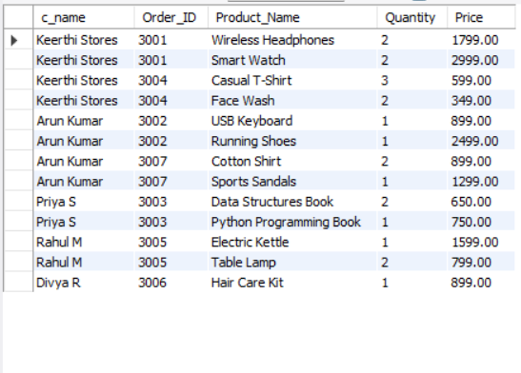
Result: These queries retrieve matching customer orders, payment details, and purchased products.
3. LEFT JOIN Examples
The LEFT JOIN operation retrieves every record from the left table and matching records from the right table. Unmatched right-side values appear as NULL.
Example 1: All Customers Including Those Without Orders
SELECT C.Customer_ID, C.Customer_Name,
O.Order_ID, O.Order_Date
FROM Customer C
LEFT JOIN Orders O
ON C.Customer_ID = O.Customer_ID;
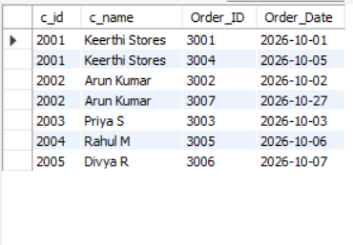
Example 2: Customers Without Purchases
SELECT C.Customer_ID, C.Customer_Name
FROM Customer C
LEFT JOIN Orders O
ON C.Customer_ID = O.Customer_ID
WHERE O.Order_ID IS NULL;

Example 3: All Products Including Products Without Sales
SELECT P.Product_ID, P.Product_Name,
OD.Order_ID, OD.Quantity
FROM Product P
LEFT JOIN Order_Details OD
ON P.Product_ID = OD.Product_ID;
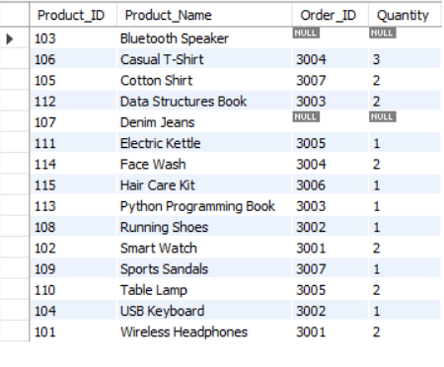
Result: These queries help identify customers without orders and products that have never been sold.
4. RIGHT JOIN Examples
The RIGHT JOIN operation retrieves all records from the right table, along with matching records from the left table.
Example 1: All Orders with Customer Information
SELECT O.Order_ID, O.Order_Date, O.Order_Status,
C.Customer_ID, C.Customer_Name
FROM Customer C
RIGHT JOIN Orders O
ON C.Customer_ID = O.Customer_ID;
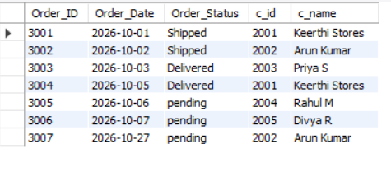
Example 2: Orders Without Matching Customer Details
SELECT O.Order_ID, O.Order_Date, O.Order_Status
FROM Customer C
RIGHT JOIN Orders O
ON C.Customer_ID = O.Customer_ID
WHERE C.Customer_ID IS NULL;
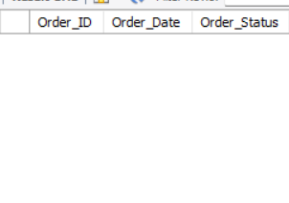
Example 3: All Payment Records with Order Details
SELECT P.Payment_ID, P.Payment_Mode,
P.Payment_Status, O.Order_ID, O.Order_Date
FROM Orders O
RIGHT JOIN Payment P
ON O.Order_ID = P.Order_ID;
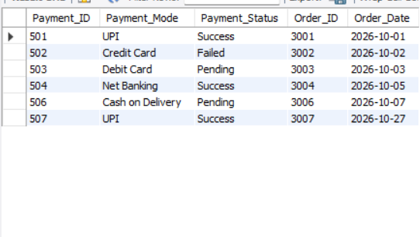
Result: These queries retrieve all orders or payment records, including unmatched records where applicable.
5. Complete Order Report
This report combines customer, product, order, quantity, amount, and payment information.
SELECT C.Customer_Name,
P.Product_Name,
OD.Quantity,
O.Order_Date,
(OD.Quantity * P.Price) AS Total_Amount,
Pay.Payment_Status
FROM Customer C
INNER JOIN Orders O
ON C.Customer_ID = O.Customer_ID
INNER JOIN Order_Details OD
ON O.Order_ID = OD.Order_ID
INNER JOIN Product P
ON OD.Product_ID = P.Product_ID
LEFT JOIN Payment Pay
ON O.Order_ID = Pay.Order_ID
ORDER BY O.Order_Date DESC;
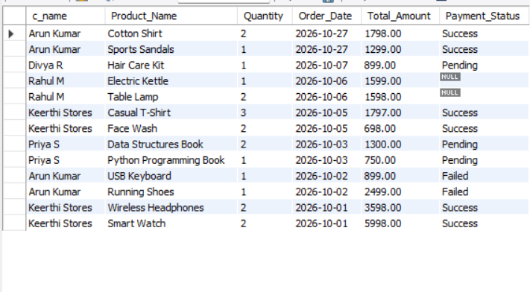
Result: The report displays purchased products, quantities, order dates, calculated line-item amounts, and payment statuses.
6. Customer Purchase History Report
Example 1: Products Purchased by a Customer
SELECT C.Customer_Name, O.Order_ID,
O.Order_Date, P.Product_Name, OD.Quantity
FROM Customer C
JOIN Orders O
ON C.Customer_ID = O.Customer_ID
JOIN Order_Details OD
ON O.Order_ID = OD.Order_ID
JOIN Product P
ON OD.Product_ID = P.Product_ID
WHERE C.Customer_ID = 1
ORDER BY O.Order_Date DESC;
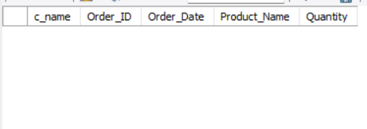
Example 2: Total Amount Spent by Each Customer
SELECT C.Customer_ID, C.Customer_Name,
COALESCE(SUM(OD.Quantity * P.Price), 0) AS Total_Spent
FROM Customer C
LEFT JOIN Orders O
ON C.Customer_ID = O.Customer_ID
LEFT JOIN Order_Details OD
ON O.Order_ID = OD.Order_ID
LEFT JOIN Product P
ON OD.Product_ID = P.Product_ID
GROUP BY C.Customer_ID, C.Customer_Name
ORDER BY Total_Spent DESC;
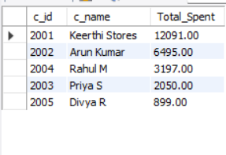
Example 3: Number of Orders Placed by Each Customer
SELECT C.Customer_ID, C.Customer_Name,
COUNT(O.Order_ID) AS Total_Orders
FROM Customer C
LEFT JOIN Orders O
ON C.Customer_ID = O.Customer_ID
GROUP BY C.Customer_ID, C.Customer_Name
ORDER BY Total_Orders DESC;
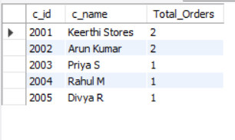
Example 4: Latest Purchase Details
SELECT C.Customer_ID, C.Customer_Name,
O.Order_ID, O.Order_Date, O.Order_Status
FROM Customer C
JOIN Orders O
ON C.Customer_ID = O.Customer_ID
WHERE O.Order_Date = (
SELECT MAX(O2.Order_Date)
FROM Orders O2
WHERE O2.Customer_ID = C.Customer_ID
)
ORDER BY O.Order_Date DESC;
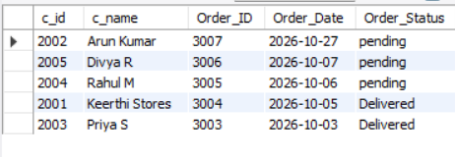
Result: These queries provide customer purchase histories, spending totals, order counts, and latest order details.
7. Multi-Table Business Reports
Report 1: Customer Order Report
SELECT C.Customer_Name, O.Order_ID,
O.Order_Date, O.Order_Status
FROM Customer C
JOIN Orders O
ON C.Customer_ID = O.Customer_ID
ORDER BY O.Order_Date DESC;
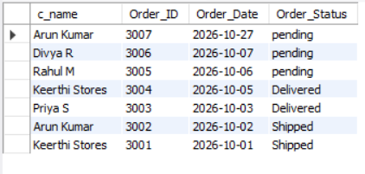
Report 2: Sales Report
SELECT P.Product_Name,
SUM(OD.Quantity) AS Quantity_Sold,
SUM(OD.Quantity * P.Price) AS Total_Revenue
FROM Product P
JOIN Order_Details OD
ON P.Product_ID = OD.Product_ID
JOIN Orders O
ON OD.Order_ID = O.Order_ID
WHERE O.Order_Status = 'Delivered'
GROUP BY P.Product_ID, P.Product_Name
ORDER BY Total_Revenue DESC;
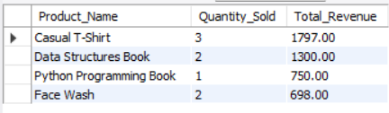
Report 3: Payment Analysis Report
SELECT Payment_Mode,
COUNT(*) AS Number_Of_Transactions,
SUM(
CASE
WHEN Payment_Status = 'Success' THEN 1
ELSE 0
END
) AS Successful_Payments
FROM Payment
GROUP BY Payment_Mode
ORDER BY Number_Of_Transactions DESC;
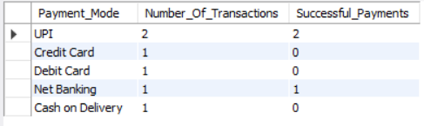
Report 4: Customer Purchase Analysis
A. Top Purchasing Customers
SELECT C.Customer_ID, C.Customer_Name,
SUM(OD.Quantity * P.Price) AS Total_Spending
FROM Customer C
JOIN Orders O
ON C.Customer_ID = O.Customer_ID
JOIN Order_Details OD
ON O.Order_ID = OD.Order_ID
JOIN Product P
ON OD.Product_ID = P.Product_ID
WHERE O.Order_Status = 'Delivered'
GROUP BY C.Customer_ID, C.Customer_Name
ORDER BY Total_Spending DESC
LIMIT 5;
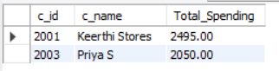
B. Customers with Maximum Orders
SELECT C.Customer_ID, C.Customer_Name,
COUNT(O.Order_ID) AS Total_Orders
FROM Customer C
JOIN Orders O
ON C.Customer_ID = O.Customer_ID
GROUP BY C.Customer_ID, C.Customer_Name
ORDER BY Total_Orders DESC
LIMIT 5;
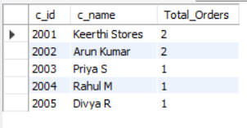
C. Customers with Highest Spending
SELECT C.Customer_ID, C.Customer_Name,
SUM(OD.Quantity * P.Price) AS Total_Spending
FROM Customer C
JOIN Orders O
ON C.Customer_ID = O.Customer_ID
JOIN Order_Details OD
ON O.Order_ID = OD.Order_ID
JOIN Product P
ON OD.Product_ID = P.Product_ID
WHERE O.Order_Status = 'Delivered'
GROUP BY C.Customer_ID, C.Customer_Name
ORDER BY Total_Spending DESC
LIMIT 5;
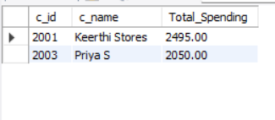
Result: The business reports help analyze customer orders, product sales, payment transactions, customer spending, and order frequency.
8. Conclusion
The Week 8 project demonstrates the use of INNER JOIN, LEFT JOIN, and RIGHT JOIN to retrieve related information from multiple tables in an E-Commerce database. The queries provide insights into customer purchases, product sales, payment transactions, and business performance. These operations improve understanding of relational database management and practical SQL reporting.

